AI ASSISTED CODING:
Assignment 6.4:
Name : Vaishnavi Vardineni
Hall ticket no: 2403A51431
Batch:16

Task 1: Write a Program in python as class named Student with attributes name, roll_number, and marks. complete methods for displaying details and checking if marks are above average
Code:

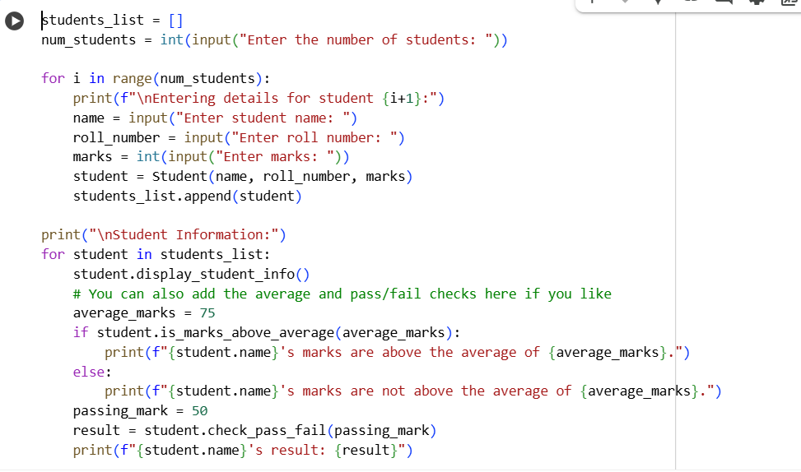

Output:
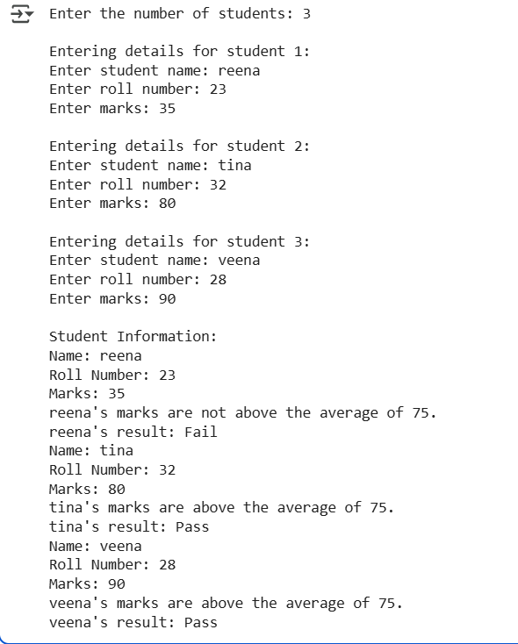

Explanation:

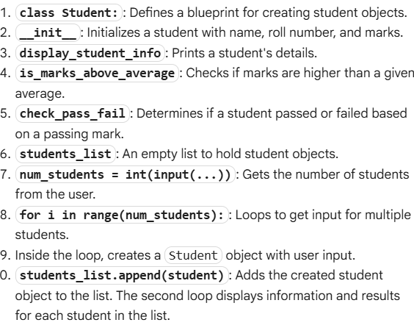
Task 2:
Write the first two lines of a for loop to iterate through a list of numbers. calculate and print the square of even numbers only.
Code:
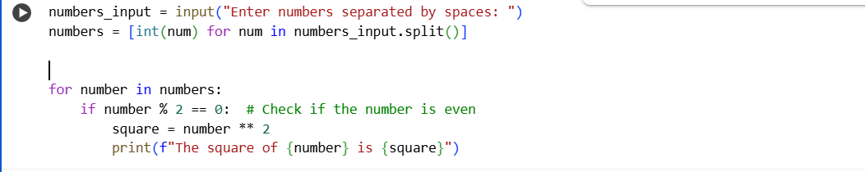
Output:
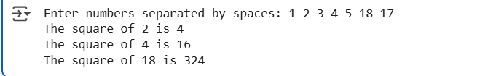

Explanation:

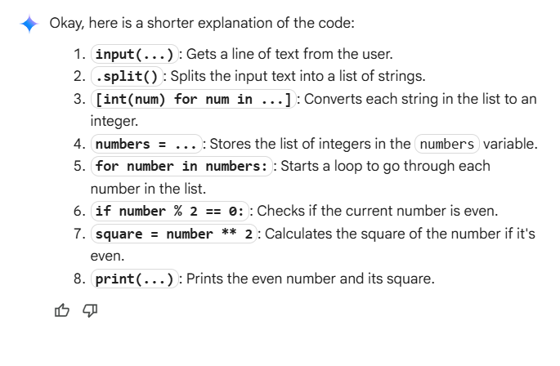

Task 3:
Create a Python class named BankAccount with attributes: account_holder and balance. Implement
methods for deposit(amount), withdraw(amount), and check for insufficient balance during
withdrawal.

Code:
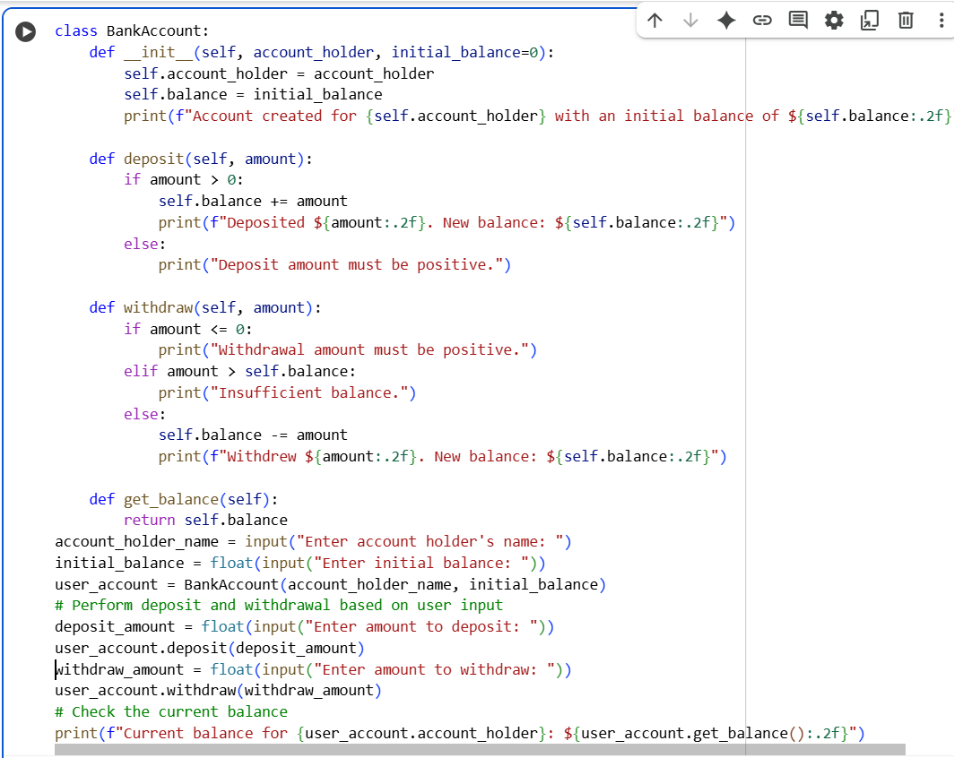

Output:
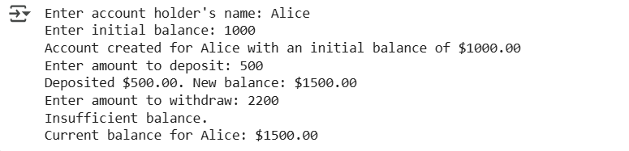
Explanation:
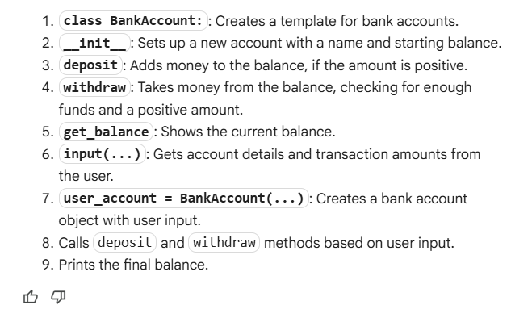
Task 4:
Define a list of student dictionaries with keys "name" and "score". Write a while loop to print the names of students who scored more than 75.
Code:
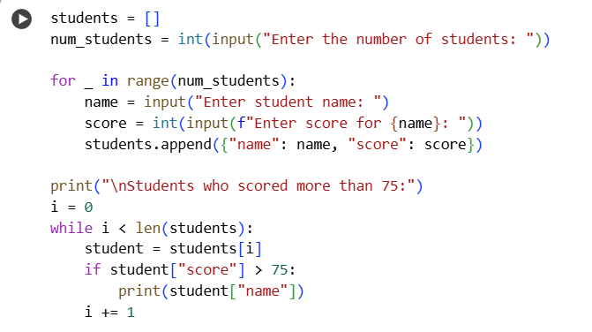

Output:
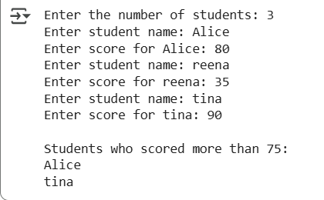
Explanation:
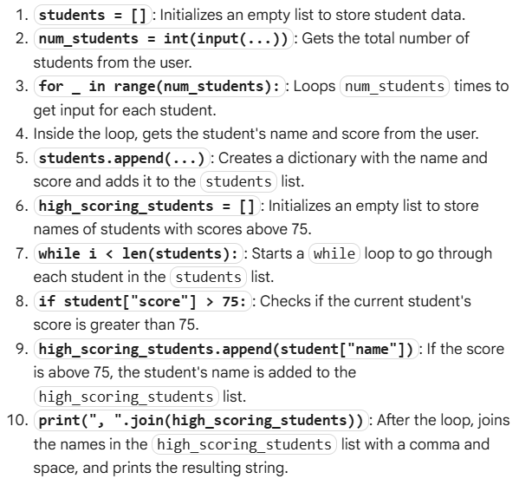

Task 5:
Begin writing a Python class named ShoppingCart with an empty items list. Generate methods to add_item(item, price), remove_item(item), and use a loop to calculate the total bill with conditional discounts applied.
Code:
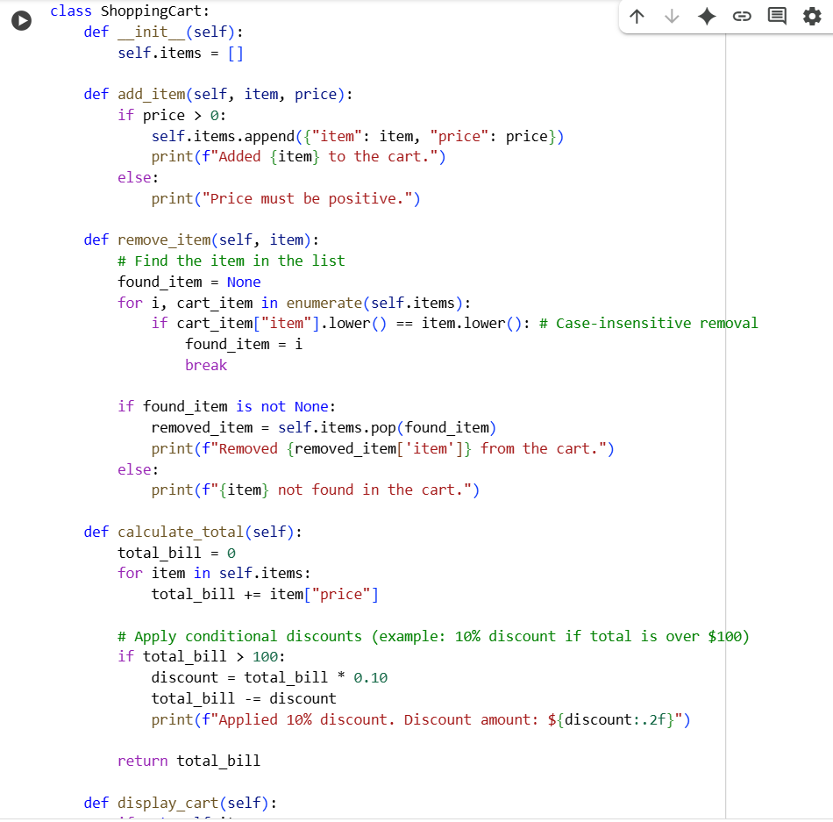
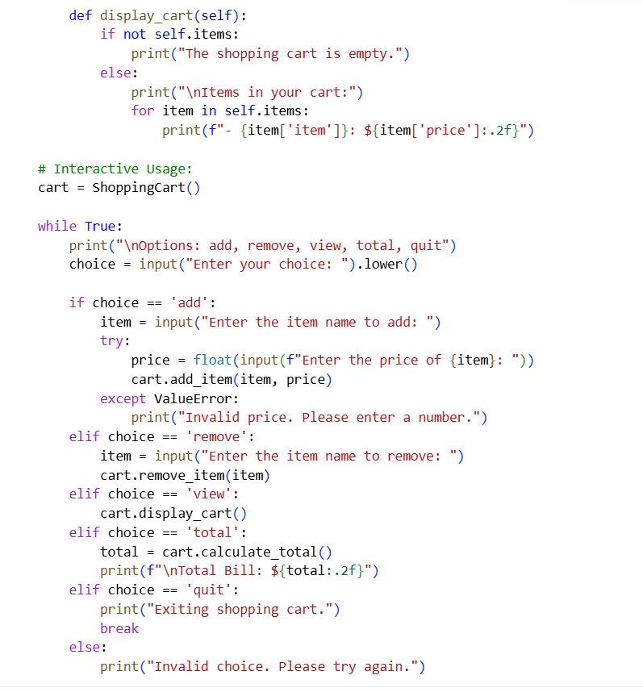

Output:
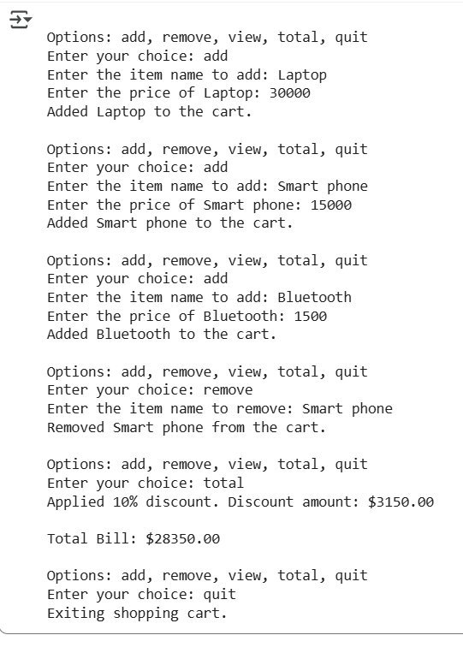

Explanation:
